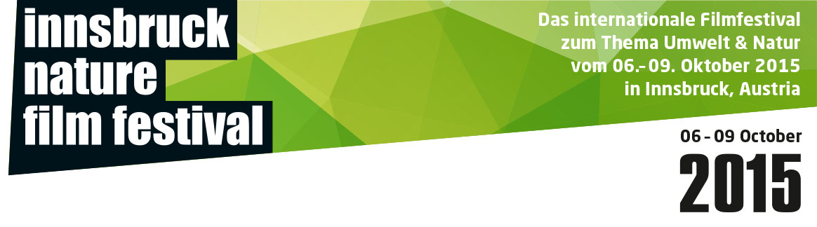
INNSBRUCK NATURE FILM FESTIVAL 2015
RESULTS

GRAND PRIZE OF THE CITY OF INNSBRUCK
Worth € 3.000,-
Category: DOCUMENTARIES Nature
donated by: The City of Innsbruck
Winner: Oliver Goetzl, Yellowstone
Honorable Mention: Laura Rietveld, Okpik’s Dream

GRAND PRIZE OF THE CITY OF INNSBRUCK
Worth € 3.000,-
Category: DOCUMENTARIES Environment
donated by: The City of Innsbruck
Winner: Sandrine Feydel & Denis Delastrac, Banking Nature
Honorable Mention: Ben Knight, Travis Rummel, Damnation

CANON AWARD
Canon XC10 4K Camcorder, worth € 2.000
Category: SHORT FILMS
donated by: Canon
Winner: Wendy Pillonel, Mirages
CANON AWARD
Canon XC10 4K Camcorder, worth rd. € 2.000
Category: ANIMATED SHORT FILMS
donated by: Canon
Winner: Marcel Barelli, Lucens

TIROLER TAGESZEITUNG AWARD FOR YOUNG TALENTS
Worth € 1000,-
Category: YOUNGSTERS up to 19years
donated by: Tiroler Tageszeitung
Winner: Adrian Bothe, Wilde Nächte im Tegeler Fließ
Honorable Mention: Gabriella Martinez Garza, A World divided in two Colors

TIROLER TAGESZEITUNG AWARD FOR YOUNG TALENTS
Worth € 1000,-
Category: YOUNGSTERS up to 25years:
donated by: Tiroler Tageszeitung
Winner: Sebastien Pins, A Passion of Gold and Fire
Honorable Mention: Sander van Iersel, On Your Doorstep

SPECIAL AWARDS:

SPECIAL AWARD INTERNATIONAL YEAR OF SOILS 2015
Worth € 2000,-
Best Film on the Topic of Soil
donated by: Österreichische Hagelversicherung
in cooperation with: Government of theTyrol, University of Innsbruck
Winner: Monika Pirch, 1HA 43A

SWAROVSKI OPTIK SPECIAL AWARD FOR BEST CINEMATOGRAPHY
CL Companion 10×30 by Swarovski Optik with PA-i5 Adapter for iPhone®*, worth € 1.200
donated by: Swarovski Optik
Winner: Zurück zum Urwald

TERRA MATER AUDIENCE AWARD
Worth € 2000,-
donated by: Terra Mater - Factual Studios
Winner: Alessandro Bernard & Paolo Ceretto, Waste Mandala

INNSBRUCK NATURE FILM FESTIVAL 2015

HONORABLE MENTION
YOUNG TALENTS <19

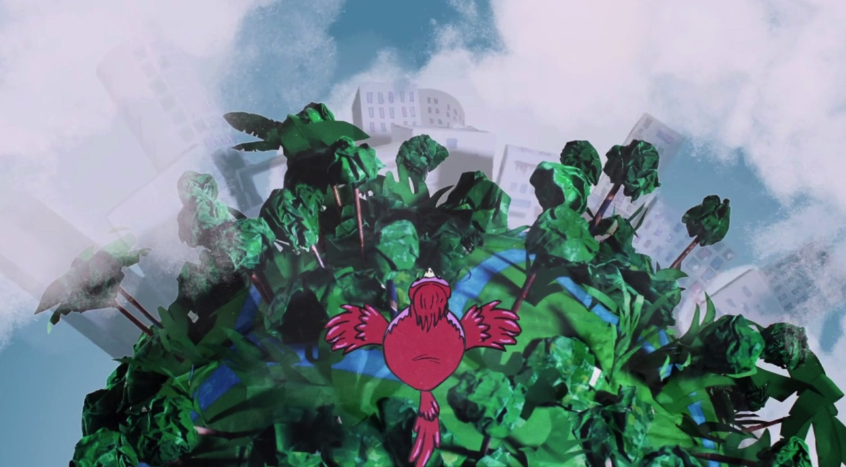

A WORLD DIVIDED IN TWO COLORS
Gabriela Martinez Garza
Mexico, 2015
00:07:00

INHALT
Our world is divided between wise nature and excessive industrialization, which due to human thoughtlessness degenerates into excess chaos and pollution… Will the animals be the ones to show us the correct way out?

JURYSTATEMENT HONORABLE MENTION
A film project of fifteen children and two adults. The film stands out with its very interesting and complex stop motion technique and covers a topic that concerns all of us. With a great amount of narrative talent the contrast between nature and the industrialized world is visualized.

WINNER
YOUNG TALENTS <19

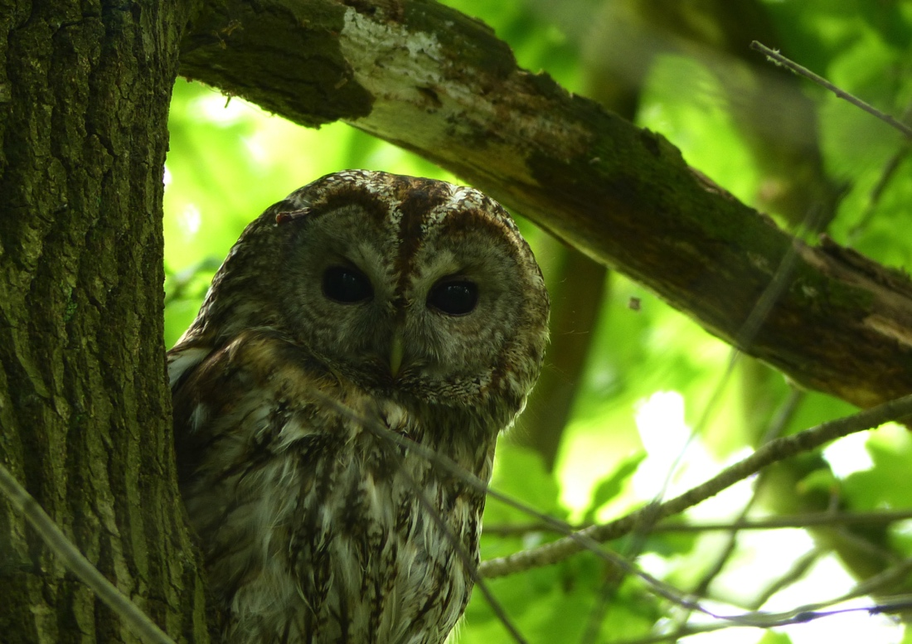

WILDE NÄCHTE IM TEGELER FLIESS
Adrian Bothe
GERMANY, 2014
00:06:33

INHALT
In the north of Berlin a stretch of deep green meanders through urban space: the "Tegeler Fließ". A small brook flows past riparian forests and wet meadows, below highways and railroad tracks. Here, wild boars, tawny owls, beavers and other wildlife live quietly amidst the German capital. The film accompanies some wild animals in their everyday life and documents the rare species of this habitat.

JURYSTATEMENT WINNER
Here, someone is on the best way to become a professional nature filmmaker. With much patience, persistence and love for detail, this film shows wild nature at a place where you wouldn't expect it: An idyll on the outskirts of Berlin.

HONORABLE MENTION
YOUNG TALENTS <25

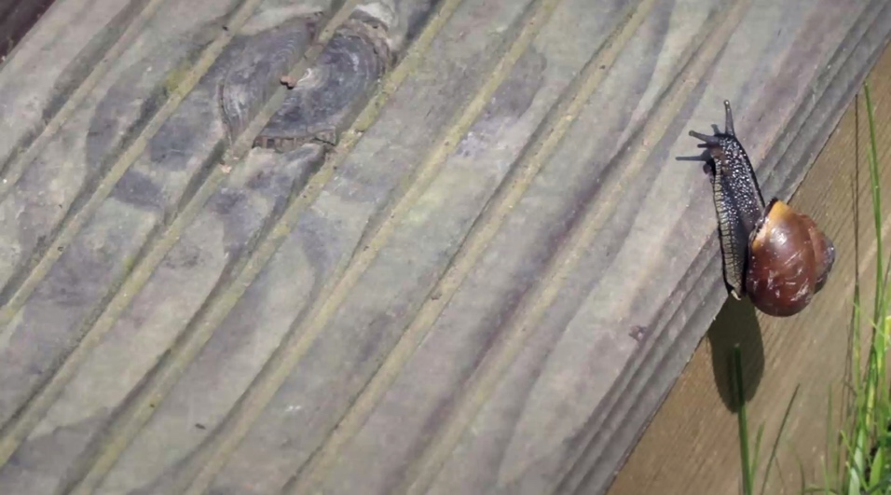

ON YOUR DOORSTEP
Sander van Iersel
UK, 2014
00:11:37

When asked where nature could be found, a random stranger would quite possible answer: the forest, jungle or savannah; somewhere far away. But sometimes we forget that nature can be found far closer than we expect it to be.
In "On Your Doorstep" the common back garden is explored through the perspective of the species that live there, how they survive and thrive and together form a small ecosystem.
The film was made as the final dissertation of Sander van Iersel for his MA course in Wildlife Documentary Production. The film was edited by a team that completely consisted of ambitious students.

JURYSTATEMENT HONORABLE MENTION
An unusual look at nature right at your doorsteps: fast-motion shots make peas dance and snails race. With simple means, the enchanting details of a private garden are made an experience.

WINNER
YOUNG TALENTS <25

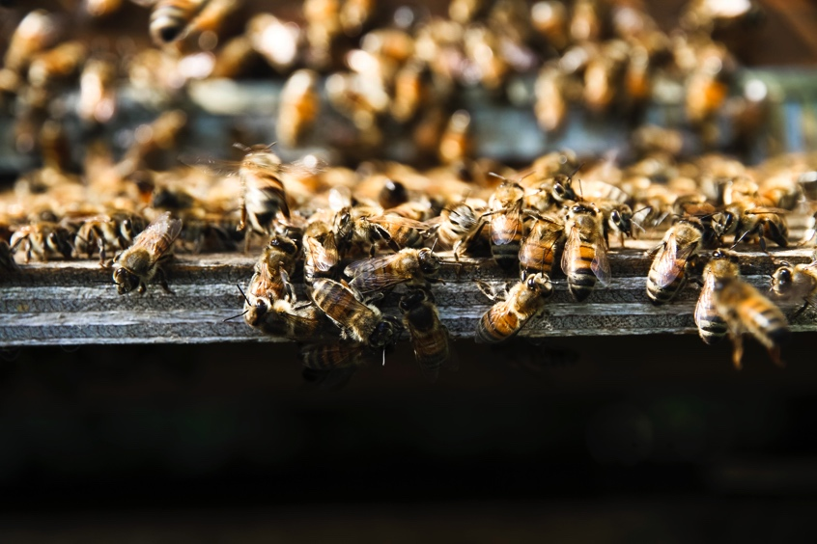

A PASSION OF GOLD AND FIRE
Sebastien Pins
France, 2015
00:06:05

A beekeeper tells us about the worries he has about his apiary school. Although the bees are in critical danger and need our help now as much as ever, he struggles to find pupils to teach them the art of beekeeping and also to pass his school to one of them. With breathtaking images, Sebastien Pins perfectly captures the stressed state of mind André Fontignie is in right now. The film shows us that not only the bees are in danger, but also the beekeepers.

JURYSTATEMENT WINNER
This film is a wonderful portrait of a beekeeper. With impressive images and gentle montage, a very topical problem is covered. The film casts a very loving glance at a beekeeper whose comprehensive knowledge is about to be lost because he can't find a successor.

WINNER
ANIMATIONS

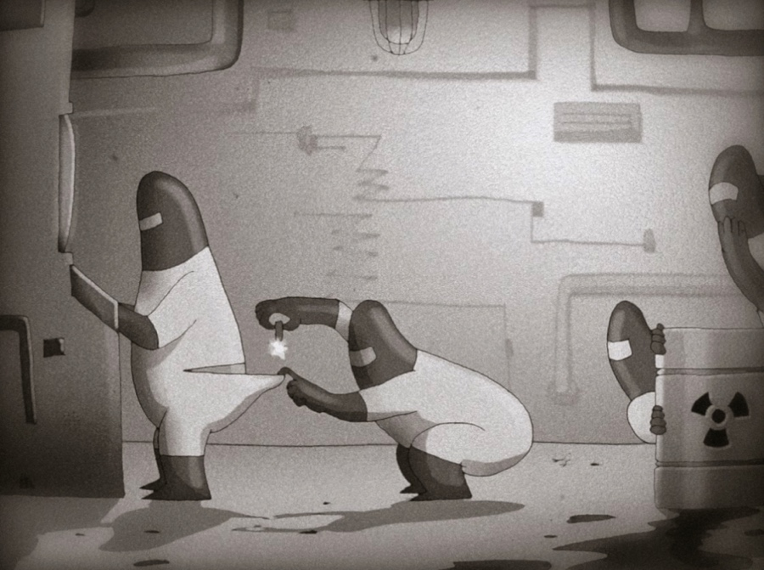

LUCENS
Nadasdy Film
SWITZERLAND, 2015
00:06:30

The story of the first nuclear power plant 100% made in Switzerland… but also the last one.

JURYSTATEMENT WINNER
With a lot of irony, the techniques of propaganda films are employed to turn messages upside down. In the simplistic animated cartoon style of the twenties, a caricature of the nuclear power program is presented and exposed to be wrong. The author creates a symbol of human arrogance and ignorance, narrated with humor und ease.

WINNER
SHORT FILMS

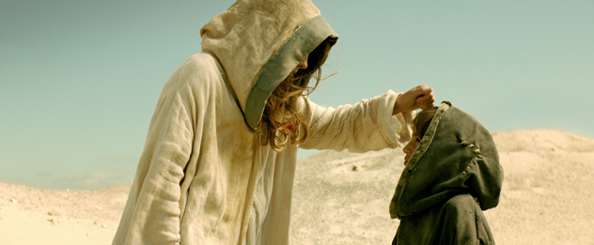

MIRAGES
Wendy Pillonel
WITZERLAND, 2014
00:15:00

It hasn’t rained for years and the Earth has dried out. Human beings live in cliffs. One day, Riham finds his father dying in the desert. The boy decides to look for water to save him. His sister Marine wants to prevent him because the sun makes people go crazy. However, a mysterious engineer maintains that he knows where the water is hiding.

JURYSTATEMENT WINNER
The poetic style of the film narrates the dread of a world without water. Highly demanding camera work stages a hostile dessert world, a fata morgana of convincing aesthetic power.

HONORABLE MENTION
DOCUMENTARIES NATURE

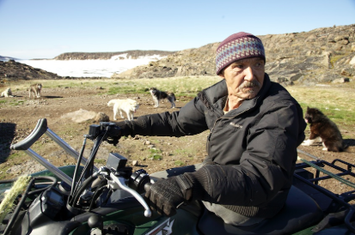

OKPIKS' DREAM
Laura Rietveld
CANADA, 2015
01:13:00

Harry Okpik dreamed of becoming a dog musher. But when government agents shot his and thousands of other Inuit huskies across the Canadian Arctic, 11-year-old Harry saw the sky turn red and thought his dream forever destroyed. Now, fifty years later, Harry Okpik reflects on the tragedy of the Dog Slaughter and the accident that led to the loss of his leg. Follow Harry through the arctic seasons as cares for his huskies and prepares for Ivakkak - a 600 km dog sled race across the Canadian Arctic. A race with the greater purpose: to bring back the nearly eradicated Inuit husky and a lost way of life.

JURYSTATEMENT HONORABLE MENTION
Many filmmakers have tried and many have failed – attempting to create films about the Inuit. This filmmaker successfully builds emotional affinity and tells the touching story of dog breeder and musher Harry Okpik. In an icy landscape, she captures images of poetic beauty without downplaying the hardship of life in northern Canadas.
WINNER
DOCUMENTARIES NATURE

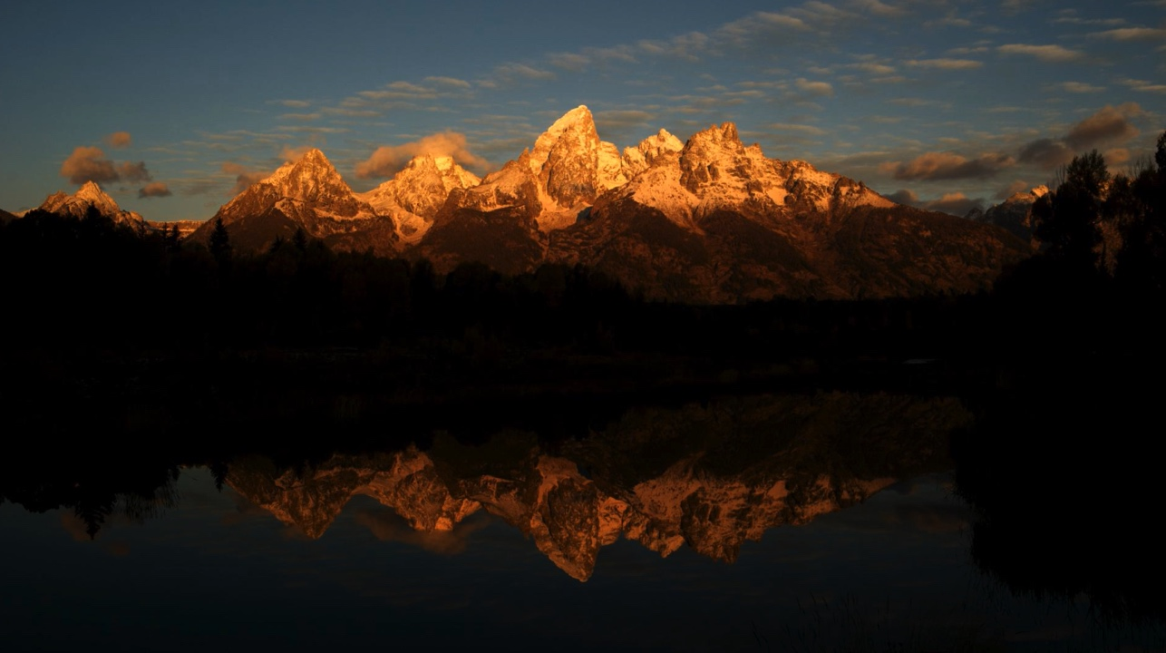

YELLOWSTONE
Oliver Goetzl
GERMANY, 2015
00:55:00

Few places are as special and unique as Yellowstone National Park – America's first national park. A wilderness jewel of vast forests and wide-open valleys, home to large bison herds, wolf packs and grizzly bears. It sits atop one of the world's largest active super volcanoes, giving rise to such iconic geothermal features as Old Faithful Geyser and Grand Prismatic Spring. As part of the landmark wildlife series AMERICA'S NATIONAL PARKS, "Yellowstone" was filmed over three years by award-winning filmmakers Oliver Goetzl and Ivo Nörenberg. Using the latest in cinematographic techniques, this film showcases Yellowstone's extraordinary wildlife and spectacular landscapes.

JURYSTATEMENT WINNER
Monumental images, exciting cutting techniques and a lot of information – this is an example of nature documentary at its best …. allowing the audience to experience animal behavior unseen before: for example, a bison calf, having fought for survival in a torrential river, now, weak and yet fearless, fights off wolves. Not only have the authors delivered proof of their first-class camera technique, they also manage to tell touching wildlife stories.

HONORABLE MENTION
DOCUMENTARIES ENVIRONMENT

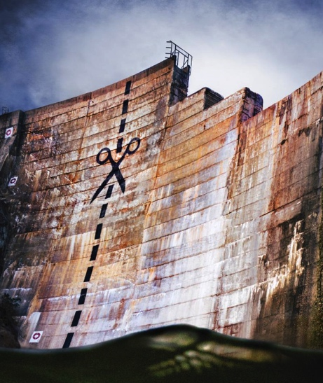

DAMNATION
Ben Knight & Travis Rummel
USA, 2014
01:27:00

This powerful film odyssey across America explores the sea change in our national attitude from pride in big dams as engineering wonders to the growing awareness that our own future is bound to the life and health of our rivers. Dam removal has moved beyond the fictional Monkey Wrench Gang to go mainstream. Where obsolete dams come down, rivers bound back to life, giving salmon and other wild fish the right of return to primeval spawning grounds, after decades without access. DamNation’s majestic cinematography and unexpected discoveries move through rivers and landscapes altered by dams, but also through a metamorphosis in values, from conquest of the natural world to knowing ourselves as part of nature.

JURYSTATEMENT HONORABLE MENTION
This film shows that sometimes, technological solutions only have a certain half life.
The authors take us on a trip showing U.S. water management from its beginnings in the 1920’s to the present.
Societal change has made it possible for rivers to reclaim their beds and open up new recreational space for people.
An emotional mix of well-researched archive pictures and impressive landscape images.
The film is proof that individuals can make a difference and change things for the better.

WINNER
DOCUMENTARIES ENVIRONMENT

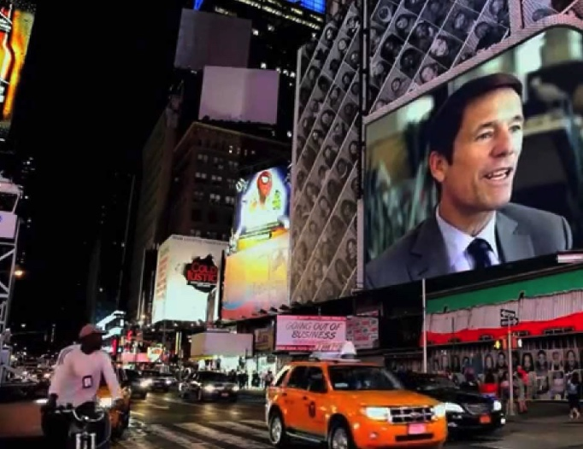

BANKING NATURE
Sandrine Feydel & Denis Delestrac
FRANCE, 2014
01:30:00

We investigate the commercialization of the natural world. Protecting our planet has become big business with companies like Merrill Lynch and JP Morgan Chase promoting new environmental markets. This involves species banking, where investors buy up vast swathes of land, full of endangered species, to enable them to sell ‘nature credits’. Companies whose actions destroy the environment are now obliged to buy these credits and new financial centres have sprung up, specializing in this trade. In countries like America, the system works very well. Many respected economists, like PavanSukhev, believe that the best way to protect nature is to put a price on it. But others fear that this market in nature could lead to companies having a financial interest in a specie's extinction. There are also concerns that - like the dotcom bubble of the 1990s or the subprime mortgage crisis of 2008 - the market in nature credits is bound to crash. And there are wider issues at stake. What guarantees do we have that our natural inheritance will be protected? And should our ecological heritage be for sale?

JURYSTATEMENT WINNER
Whoever thought that capitalizing natural resources could be a solution for our ecological crisis knows better now: thanks to the investigative approach of the directors. It is clear that the protection of endangered species should not be left to multinational companies and financial consultants. Although the topic is highly complex, the film remains exciting to the very end. The development to profit from nature as revealed by the film is frightening.

BEST FILM ON THE TOPIC OF SOIL

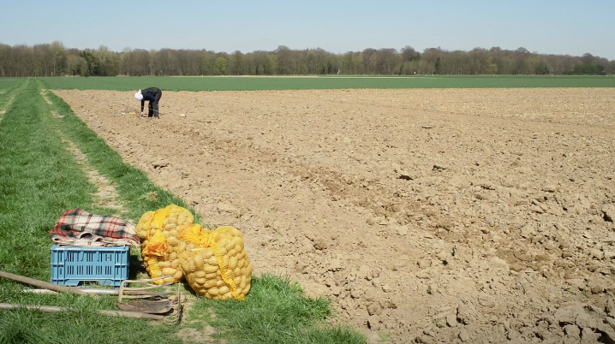

1HA 43A
Monika Pirch
GERMANY, 2014
00:51:00

With a fine sense of humor the author undertakes six attempts to approach her recently inherited property: 1,43 ha of acre. By getting closer to her field, she submerges deeply in the past, the future and the administration. All resources are challenged: Real estate, soil characteristics, work, potatoes and wind. In the course of a year and through ongoing variations of failure the author unfolds a poetic and personal view on her piece of land.

JURYSTATEMENT:
The director approaches soil with a respectful attitude and the aim to explore all of its functions and meanings. We follow her personal process of building a close relationship with her inherited piece of land. The film embraces all aspects related to the “culture” of soil: History, traditions, agricultural labor, ecology and biodiversity, economics, laws and regulations. The conclusion of the film is that soil is a scarce, non-renewable resource and its value lies beyond financial interests.

BEST CINEMATOGRAPHY

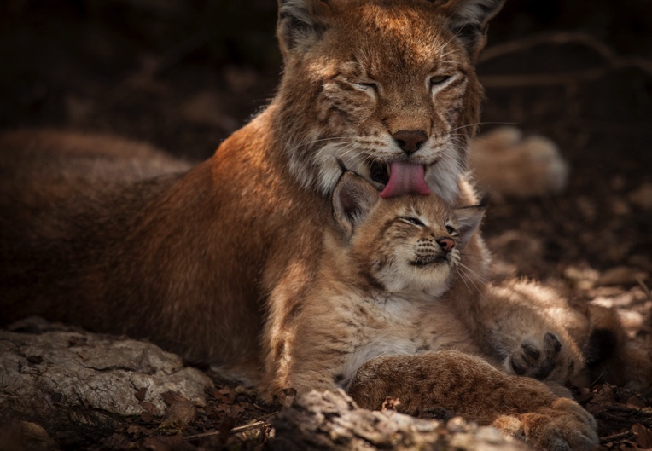

ZURÜCK ZUM URWALD-NATIONALPARK KALKALPEN
MAKING AN ANCIENT FOREST - KALKALPEN NATIONAL PARK
Rita Schlamberger
AUSTRIA, 2015
00:52:00

What if we could turn back the clock and restore Nature to her virgin state? – before man „filled the earth and subdued it“…Kalkalpen National Park was commercial timberland since the Early Middle Ages. Forestry has changed since then, but never as radically as it is changing now. This is probably the hardest decision any forest manager can take: to stop managing – and abandon the work of a hundred generations. However, in these steep limestone mountains in the heart of Austria exactly this decision has been taken. The intention, though, was not to destroy – but to recreate. The forest managers stepped down and let Nature’s own management team take over. This opens the door for new life: as the variety of trees and herbs grows and expands the forests again attract wild animals which once have left the commercial woods. So we are able to witness the unfolding of a canopy of life which hosts lynx, pygmy owl, white backed woodpeckers, a big number of fascinating insects and the weird Giant Ichneumon. The latest production of Rita and Michael Schlamberger „Making an Ancient Forest – Kalkalpen National Park“ – produced in 4K – is a coproduction of ScienceVision and Kalkalpen National Park.

JURYSTATEMENT
The cameraman successfully captures the both enchanting and spectacular atmosphere of a natural landscape. Dynamic hunting scenes of the forest animals make the film exciting. The very subtle interplay of real images and integrated animated cartoons immerses the audience in a magic world.

