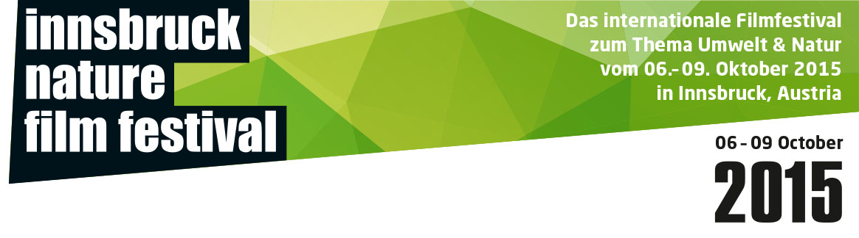**Press release, September 18, 2015**

**The Innsbruck Nature Film Festival (INFF) rolls out the green carpet**

**From October 6th-9th, the 14th edition of the Innsbruck Nature Film Festival will take place. The 60 best contributions from more than 550 submissions from 83 countries will be screened. The aim of the event is to bring out the beauty and diversity of nature on screen.**

The world's best films about the environment and nature compete during the four-day festival in the Leokino. The festival-team had to go through 552 submissons from 83 countries to make a tough selection. In both of our „Documentaries“ categories, as well as in „Short Films“, „Animated Short Films“ and contributions by „Young Talents“ numerous Austrian premieres will be shown. The film "Overcast" by Swiss director Mathias Hancke even celebrates its world premiere at the Innsbruck Nature Film Festival.

The festival will be opened on Tuesday, October 6 with a visually stunning film from the United States on how to deal with the situation of their rivers, which are heavily influenced by more than 70.000 dams nationwide: DamNation by Ben Knight and Travis Rummel.

According to the „Environmental Ombudsman of the Tyrol“ Johannes Kostenzer, the founder of the festival, film is „the perfect medium for information and to raise awareness, because it speaks to us viewers on an emotional level." In terms of a pro-environment culture a recycled sculpture by the architecture-collective columbosnext will be erected in front of the cinema. An exhibition on the occasion of the International Year of Soil in the University of Innsbruck opens its doors. Lectures on environmental topics are also in our program same as the already proven master classes for filmmakers and enthusiasts: GEO editor Katja Trippel will share her tips and tricks, animation filmmaker Annie Dissaux from Paris and Mario Kreuzer, an Austrian cinematographer, impart their knowledge to the public.

The great interest of international filmmakers in the Innsbruck Nature Film Festival shows that Innsbruck has established itself as a hotspot for nature and environmental films. For the audience it is possible to get in touch with numerous directors and producers and scent international film flair during the event.

One focus of this year's Innsbruck Nature Film Festival is the subject of soil. In addition to exhibitions and lectures the International Year of Soil (IYS 2015) – proclaimed by the United Nations - was taken as an opportunity to create a special prize for the best film on the topic of soil. During the festival the audience will slip into a new role: For the first time it chooses the winner of the „Terra Mater Audience Award“.

The grand final will be held on October 09, 2015 where numerous international filmmakers will be present for the award ceremony and the prizes will be awarded.

**Images:** are available for download here: <http://www.inff.eu/press/downloads/>

**Location:** Leokino, Anichstraße 36, 6020 Innsbruck - AUSTRIA

**Date:** October 6 until October 9, 2015

**Number of films:** 60

**Program:** detailed program can be found here: <http://www.inff.eu/program/>

**Contact:** Christoph Fintl

**Telephone:** +43/650 95 25 000

**Email:** [christoph.fintl@inff.eu](mailto:christoph.fintl@inff.eu)

